Version tiếng Anh
Logo:

Giá phòng hiển thị: Sửa lại toàn bộ giúp mình theo thông tin dưới đây nhé.
Superior Double City View | 1,300,000
Superior Triple City View | 1,800,000
Deluxe Double Balcony | 1,500,000
Deluxe Twin Balcony | 1,600,000
Luxury Double With Balcony & Bath Tub | 1,650,000
Luxury Twin With Balcony & Bath Tub | 1,750,000
Deluxe Family Balcony | 2,100,000
Family Connecting Room 1 | 2,600,000
Family Connecting Room 2 | 2,750,000

Khi click vào View Details:
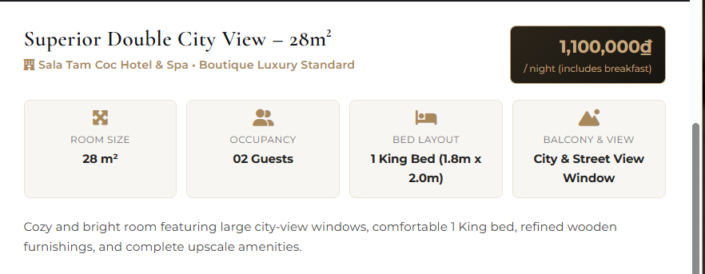
01 King Bed bên trên, xuống dòng (1.8m x2m) bên dưới. Các hạng phòng khác cũng vậy
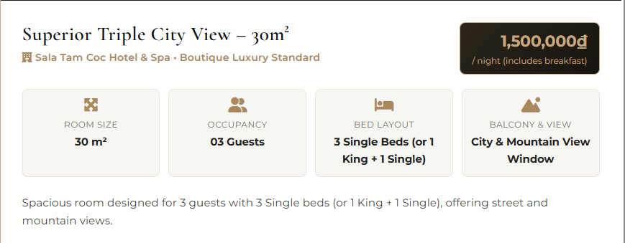
City & Moutain View Window => City & Street View Window.
Spacious room designed for 3 guests with 3 Single beds (or 1 King + 1 Single), offering street and mountain views.
- Spacious room designed for 3 guests with 3 Single beds (or 1 King + 1 Single), offering street view & balcony.
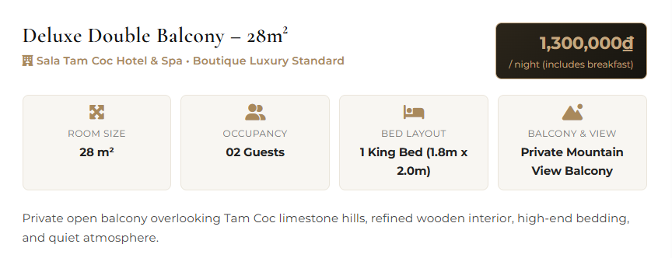
Sửa thành Private City/Moutain View Balcony.
- Private open balcony overlooking city view/Tam Coc limestone hills, refined wooden interior, high-end bedding, and quiet atmosphere.

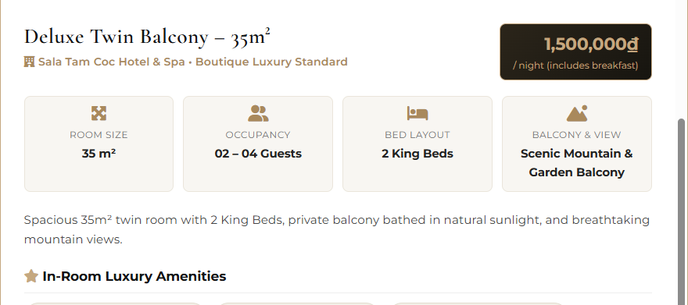
Scenic Mountain & Garden Balcony => Private City/Street View Balcony
Spacious 35m² twin room with 2 King Beds, private balcony bathed in natural sunlight, and breathtaking mountain views.
- Spacious 35m² twin room with 2 King Beds, private balcony bathed in natural sunlight, and breathtaking city/street views.

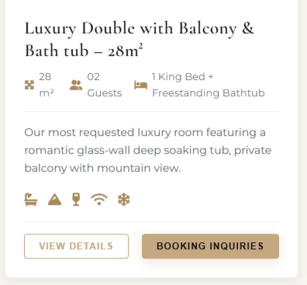
Freestanding Bathtub => Bathtub.
Panoramic Mountain Balcony & Glass Bathtub => City/Moutain View Balcony & Bathtub. Sửa cả ở 2 phòng Luxury Double và Luxury Twin.
Our most requested luxury room featuring a romantic glass-wall deep soaking tub, private balcony with mountain view.
- Our most requested luxury room featuring a romantic glass-wall deep soaking tub, private balcony with city/mountain view.
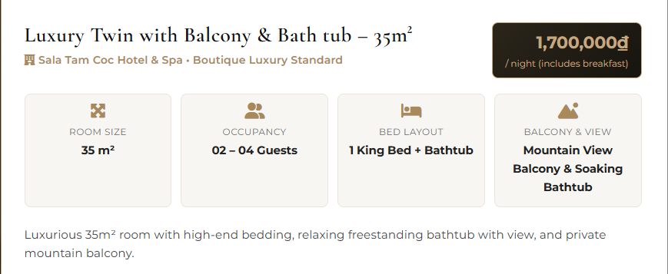
Mountain View Balcony & Soaking Bathtub => City/Street View Balcony & Bathtub.
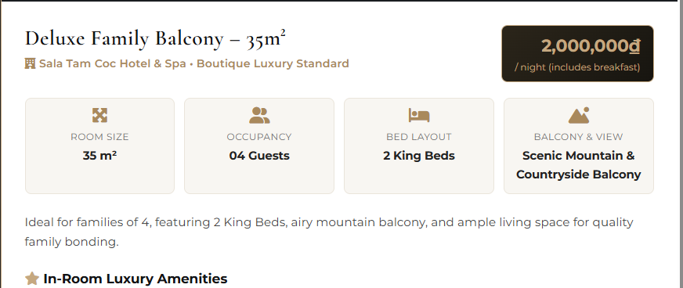
Scenic Mountain & Countryside Balcony => City/Street View Balcony
Ideal for families of 4, featuring 2 King Beds, airy mountain balcony, and ample living space for quality family bonding.
- Ideal for families of 4, featuring 2 King Beds, airy city/street balcony, and ample living space for quality family bonding.
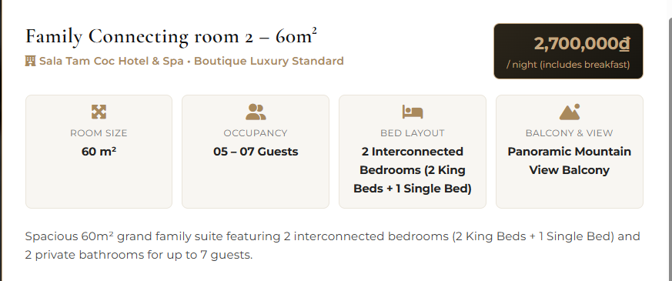
Panoramic Mountain View Balcony => City/Street View Balcony
Tất cả mô tả Smart TV (Cable & Netflix) => Smart TV, không có Cable & Netflix

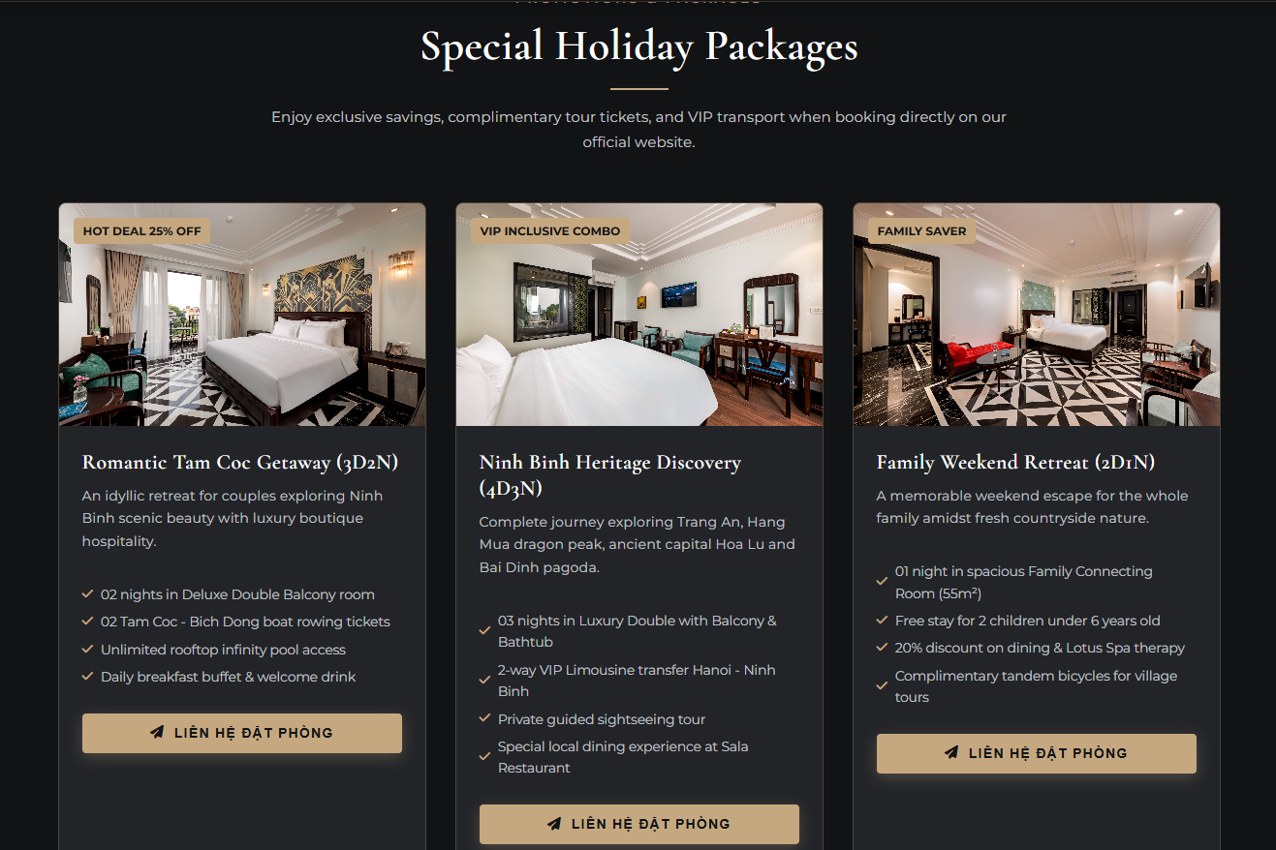
Liên hệ đặt phòng => Booking Inquiries
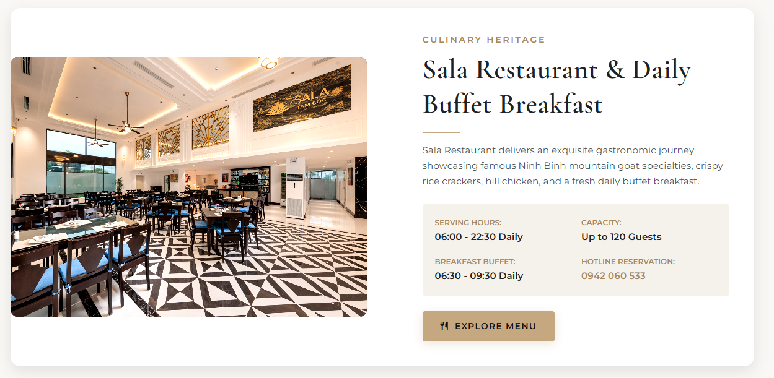
06H00 – 22H30 => 07H00 – 20H30
BREAKFAST BUFFET => BUFFET BREAKFAST
06H30 – 09H30 => 07H00 – 09H30.
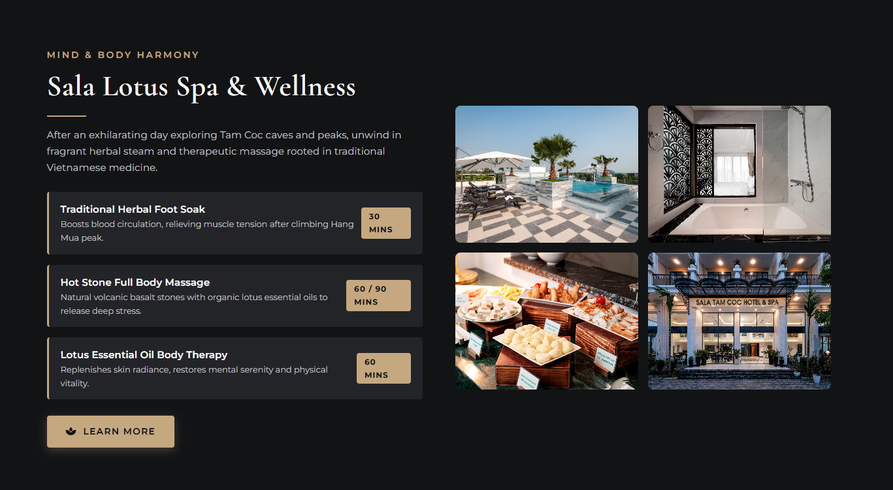
30 MINS, 60 / 90 MINS, 60 MINS cho cùng hết 1 hàng.
4 ảnh ở mục này thay lại toàn bộ bằng ảnh spa, massage chất lượng cao.
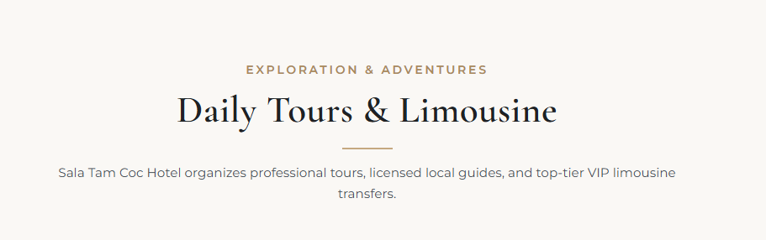
Đoạn mô tả cho về cùng 1 dòng.
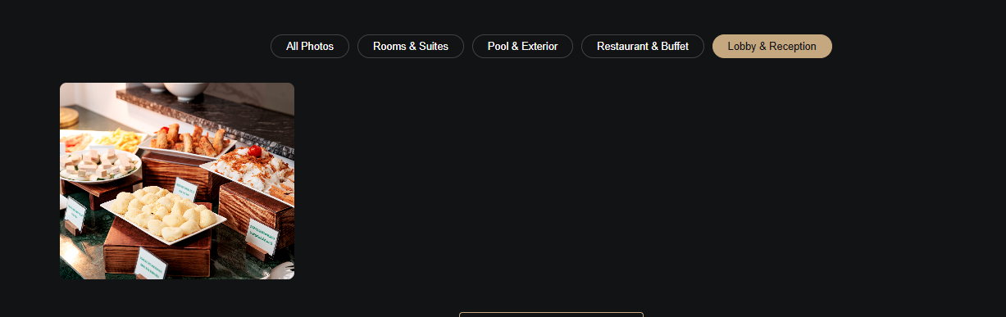
Ảnh ở Lobby & Reception chưa đúng. Bố trí giúp mình có 4 mục thì mỗi mục 4 ảnh nhé.
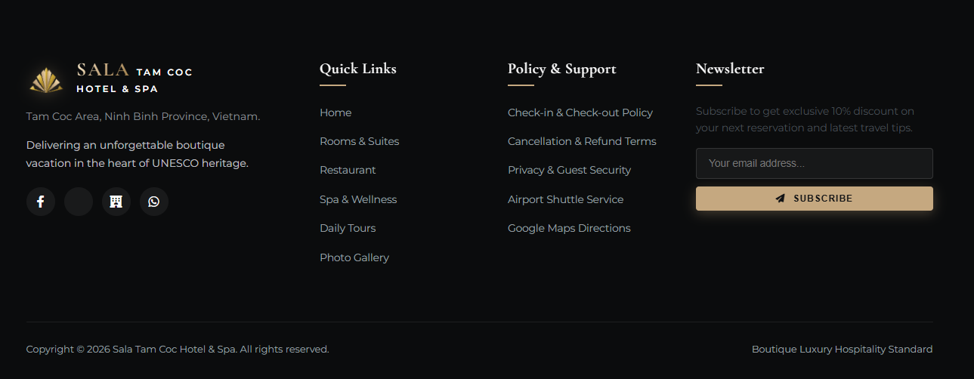
Cuối email sửa lại logo như bên trên, chữ TAM COC cho xuống dòng dưới cùng Hotel & Spa.
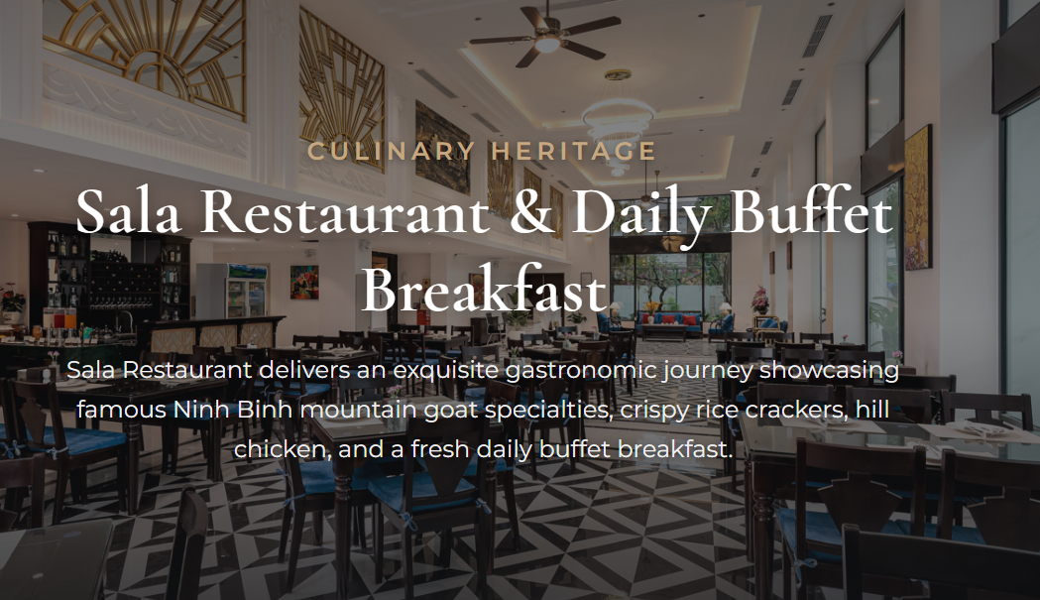
Sala Restaurant & Daily Buffet Breakfast có cho cùng 1 dòng được không ?
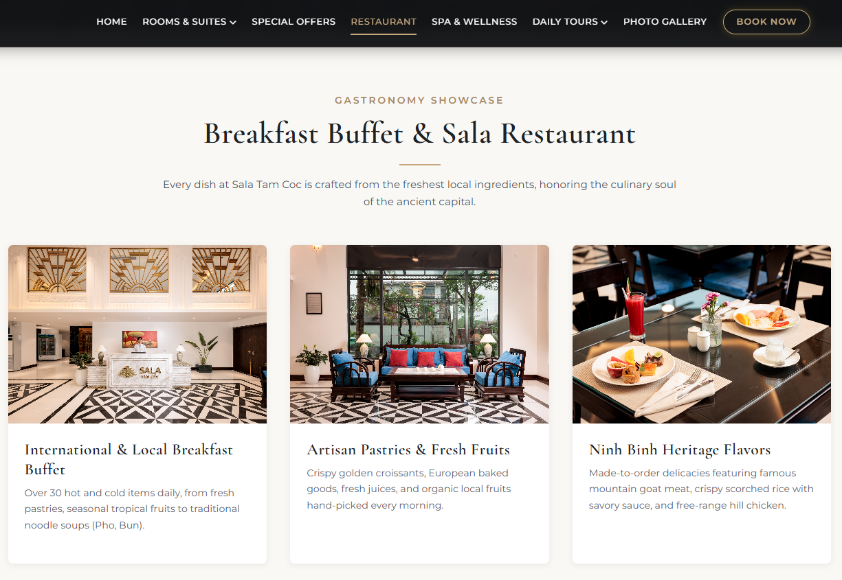
Breakfast Buffet & Sala Restaurant => Buffet Breakfast & Sala Restaurant
International & Local Breakfast Buffet => International & Local Buffet Breakfast
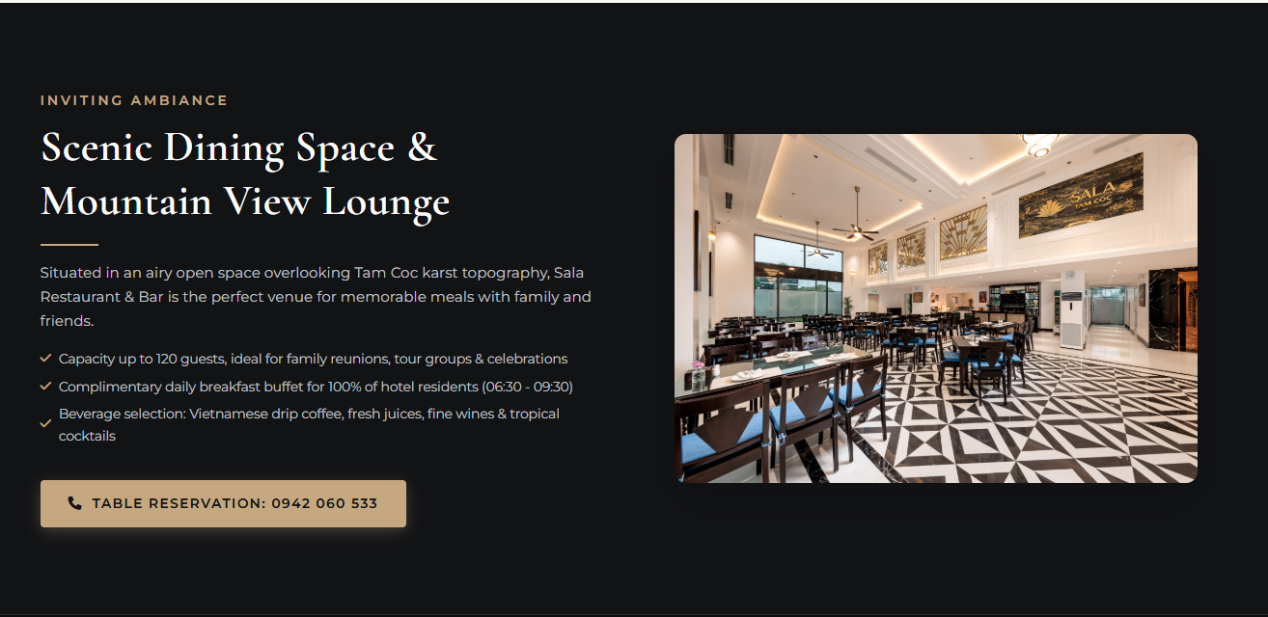
Complimentary daily breakfast buffet for 100% of hotel residents (06:30 - 09:30)
- Complimentary daily buffet breakfast for 100% of hotel residents (07:00 - 09:30)
Table Reservation: 0942 060 533 => Reservation: 0942 060 533
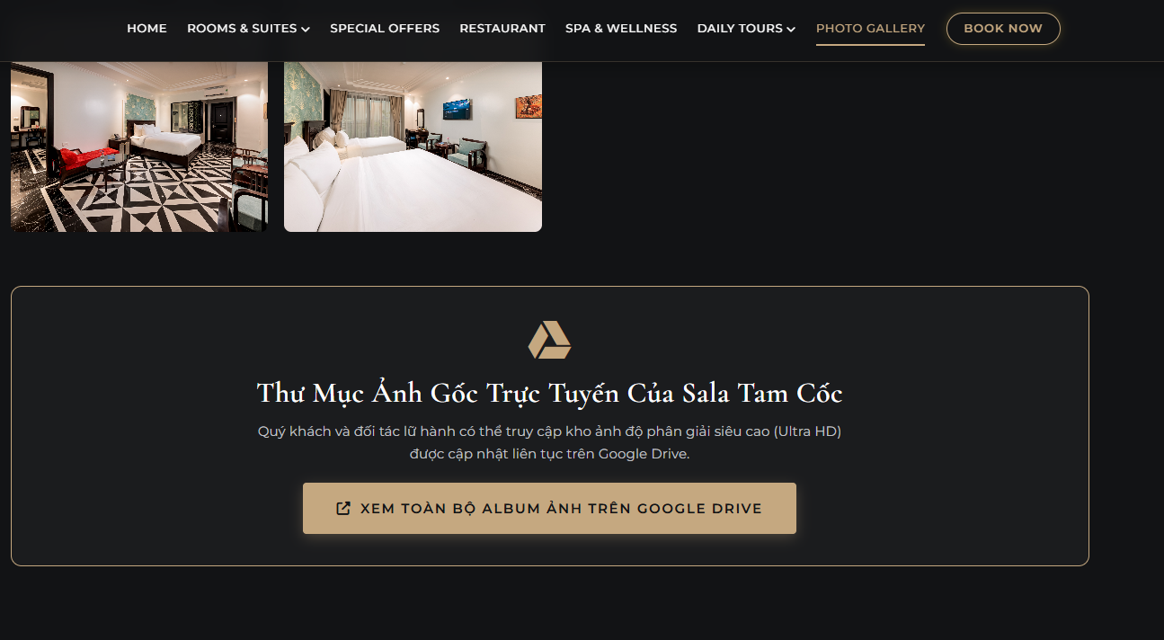
Bỏ phần Google Drive này đi

